Website Development Resources

Prototype link:

<https://www.figma.com/proto/QZ3HbsJlTJ67o2uhCPFo9w/GDG-Aba?page-id=81%3A925&node-id=81%3A926&scaling=min-zoom&starting-point-node-id=81%3A926>

UI design link:

<https://www.figma.com/file/QZ3HbsJlTJ67o2uhCPFo9w/GDG-Aba?node-id=224%3A1934>

Note: you can download needed contents like images etc from the UI link above

Mobile App Development Use Case

You are to build a tech career guild application where those seeking to start a career in tech and get a brief guidance on how to get started in any field of choice.

Below is an image that gives you an insight of what is expected of you.

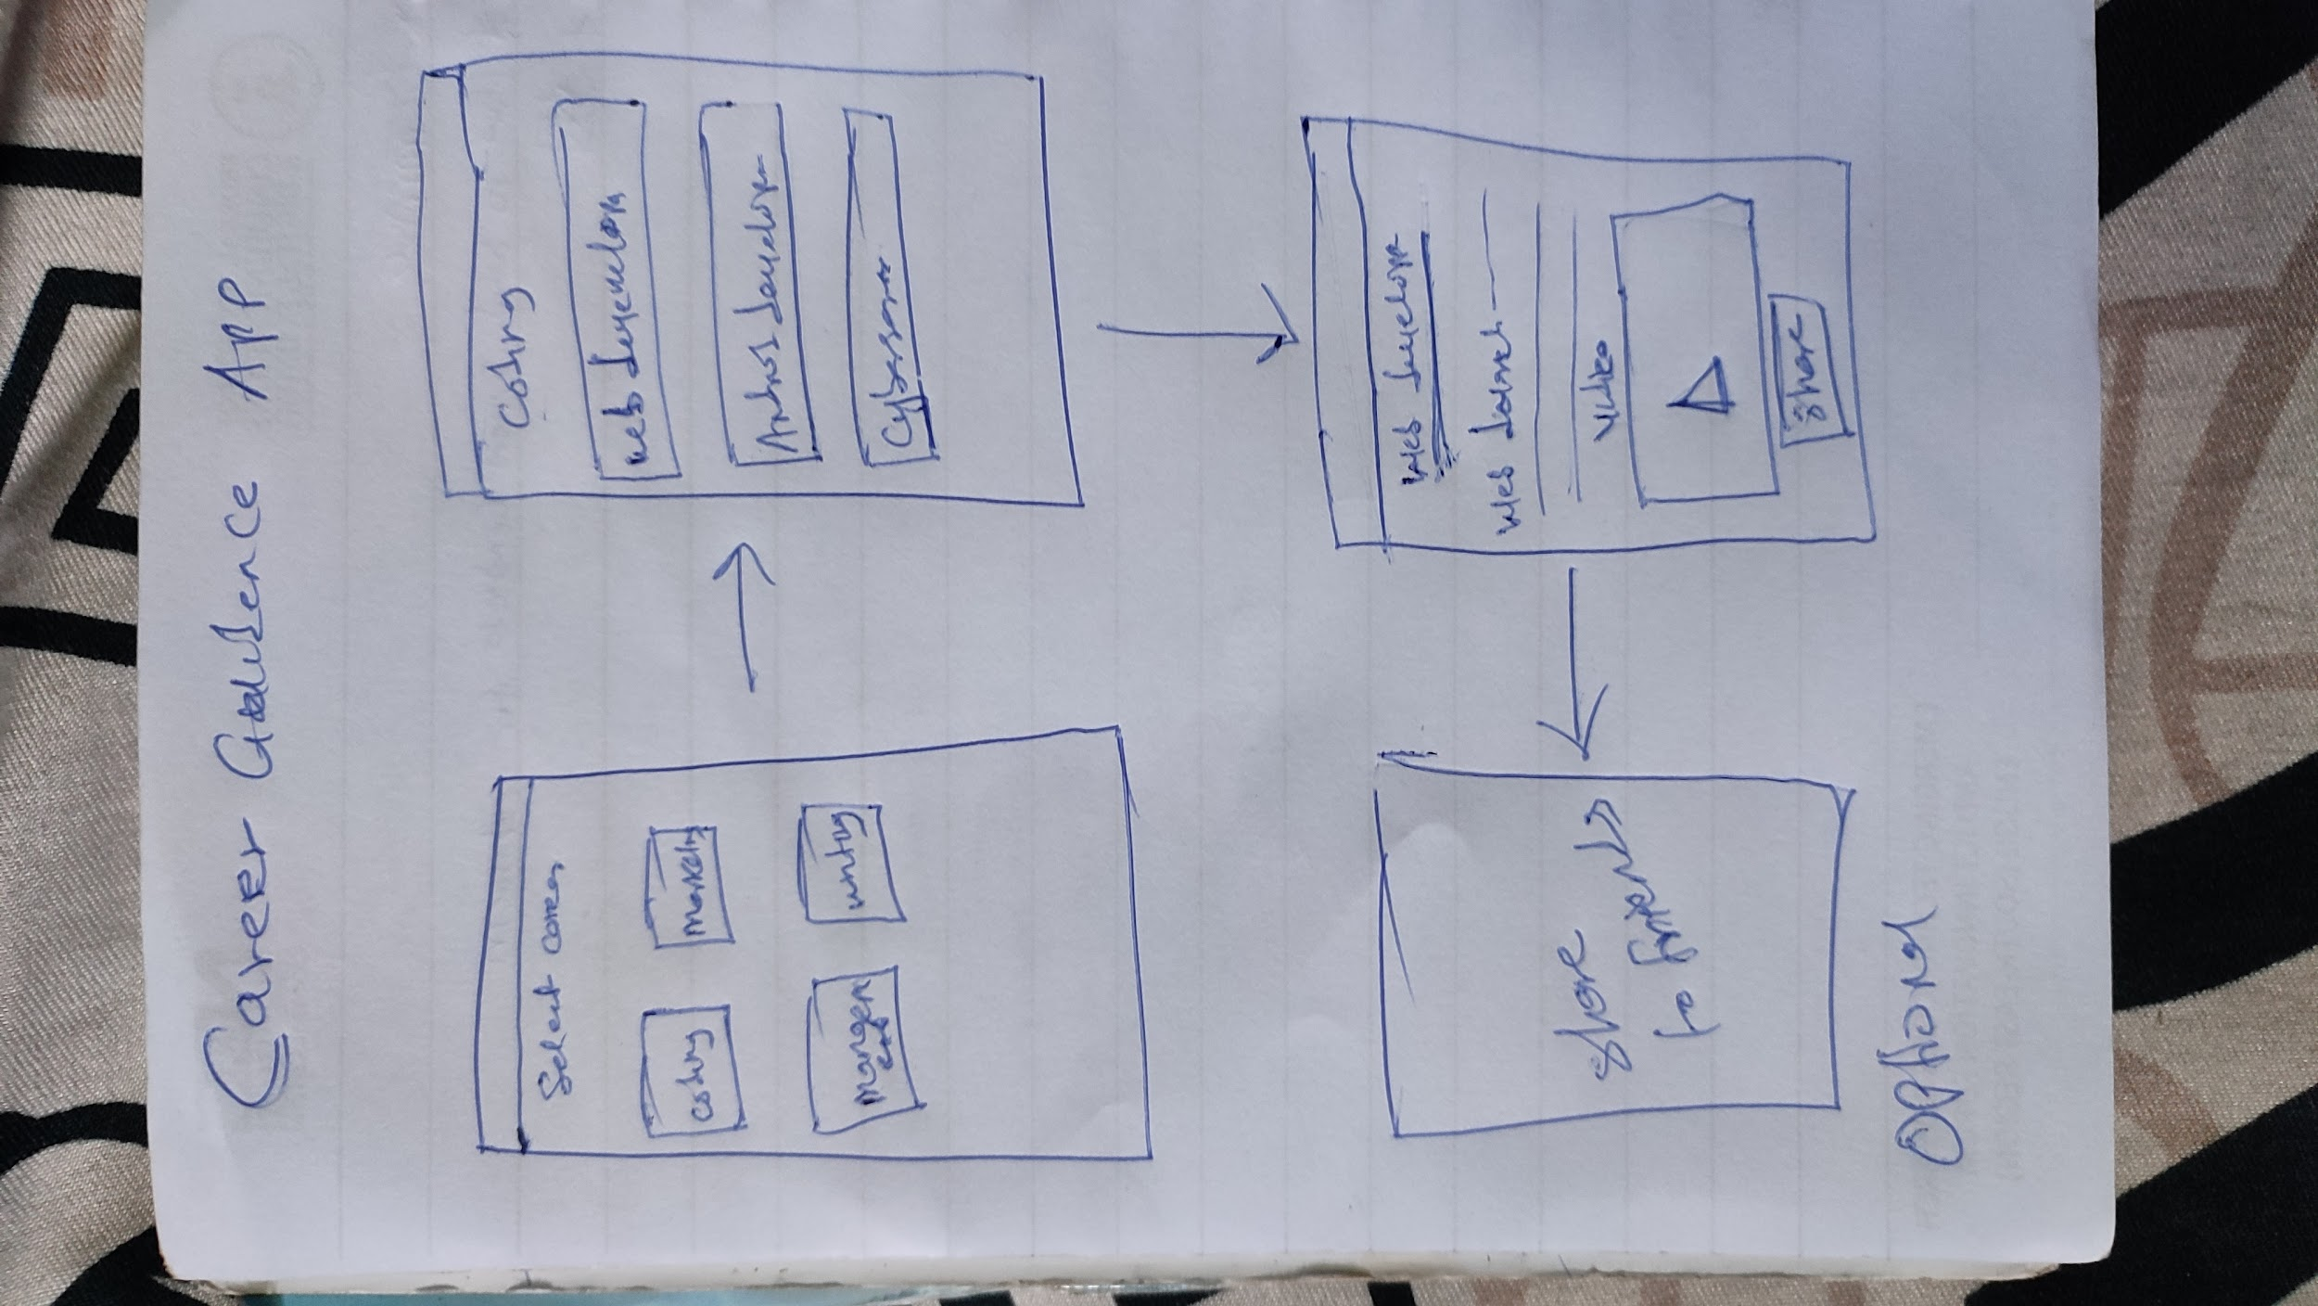

Need the GDG Aba logo? Check the link on Web UI design and download it